Project 1

# **PART 1:**

Creating terraform service principle in azure to connect the terraform machine in the azure and to create two virtual machines in azure platform using terraform and creating the Jenkins environment in those two virtual machines.

* **Creating service principle:**

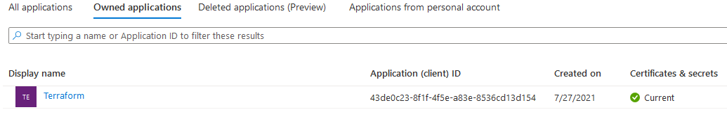

Created service principle for terraform and added owner role to terraform.

* Creating main.tf and vars.tf to create two virtual machine in azure platform and to install required software in those virtual machine to create Jenkins environment.

Virtual machine 1: jenkinsmaster

Virtual machine 2: jenkinsslave

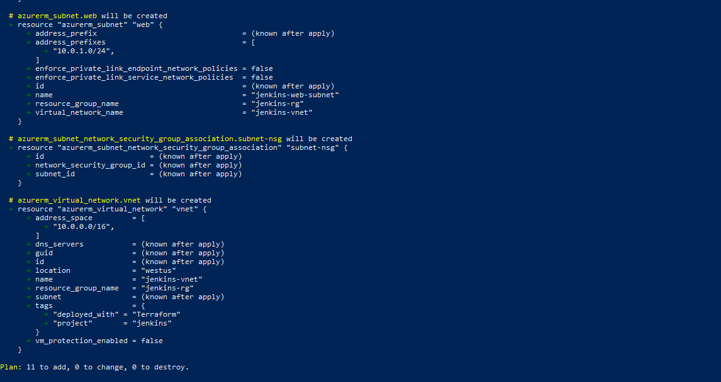

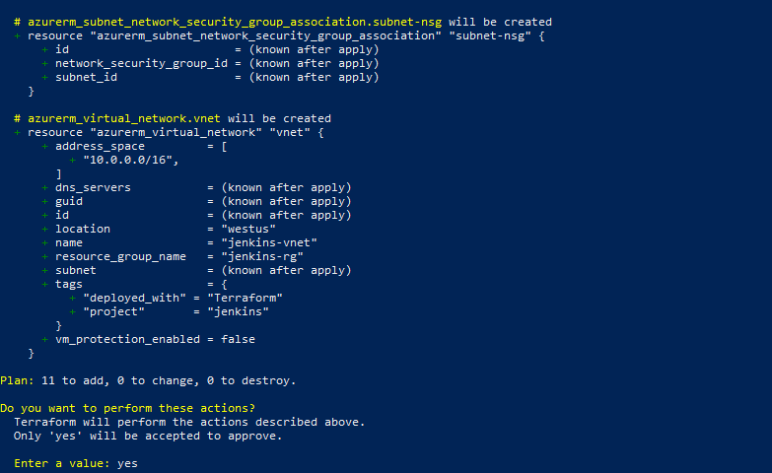

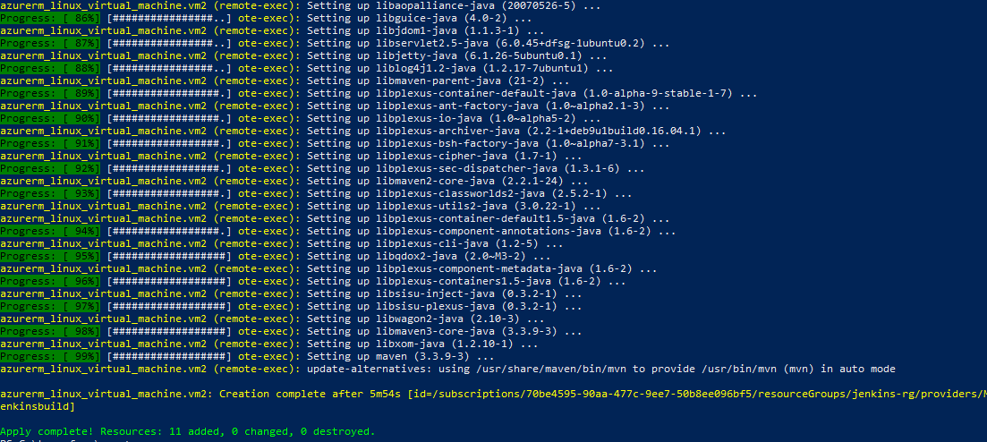

* **Created two virtual machines with required software for Jenkins environment and installing requird plugins.**

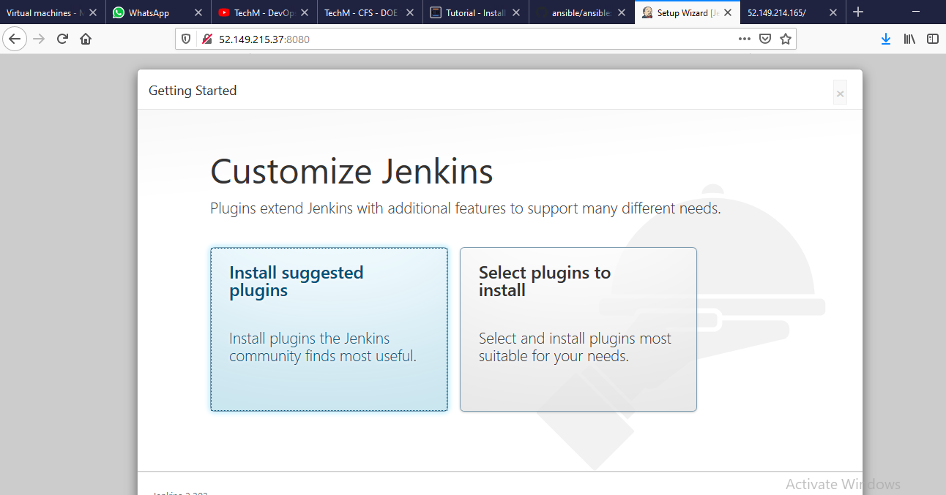

# **Part 2-phase 1:**

* Creating Maven Project with Archtype as web application in eclipse .

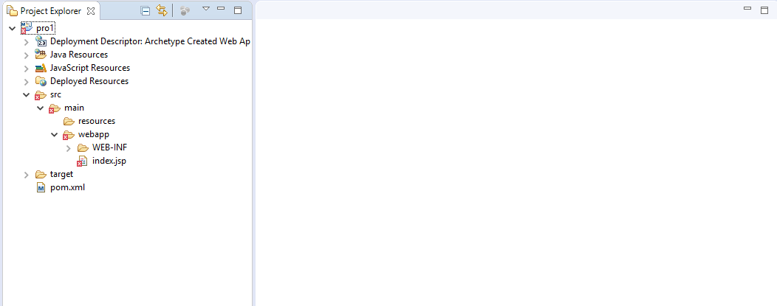

* Modifying index.jsp

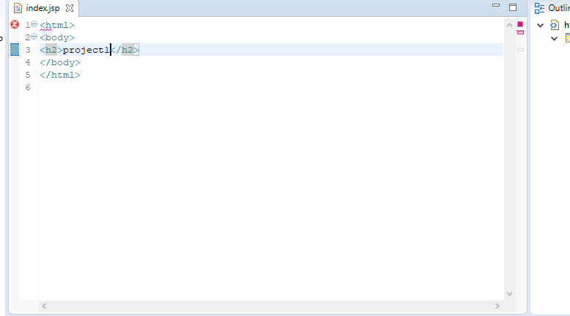

* Running maven clean install.

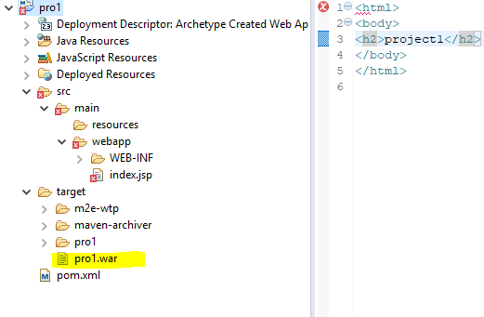

# **Part2-Phase2:**

* Creating Docker file and using tomcat as base image.

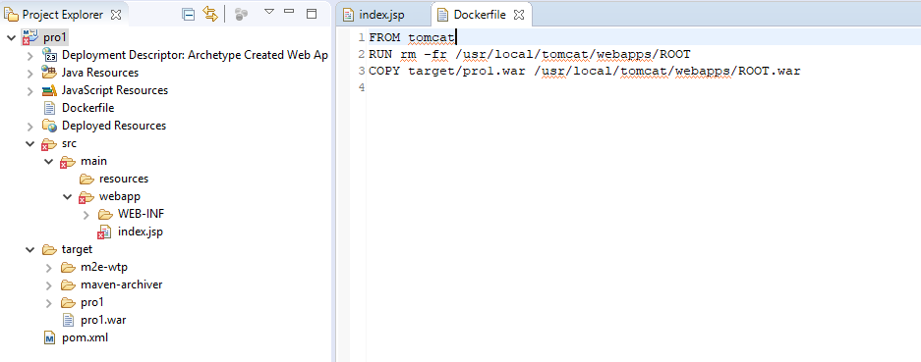

* Creating the Docker Continer using the dockerfile and accessing the application.

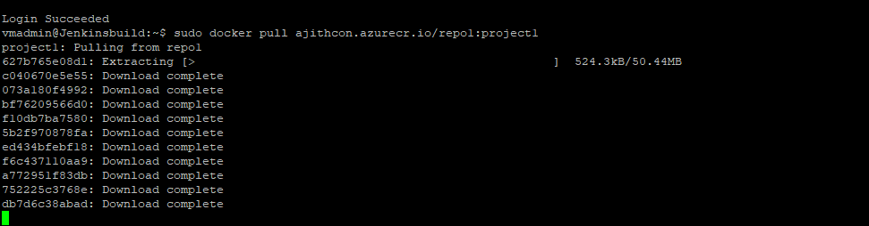

* Fetching the images to docker server and creating a continer using the image which is created in the eclipse

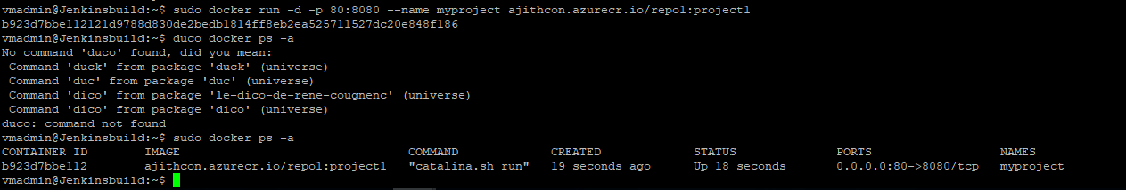

* Accessing the application .

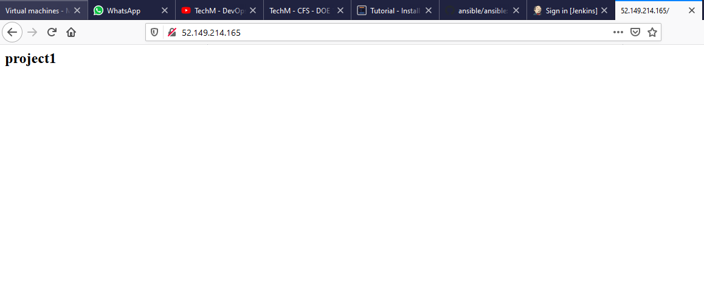

# **Part2-phase 3:**

* Creating a GIt hub Repo:

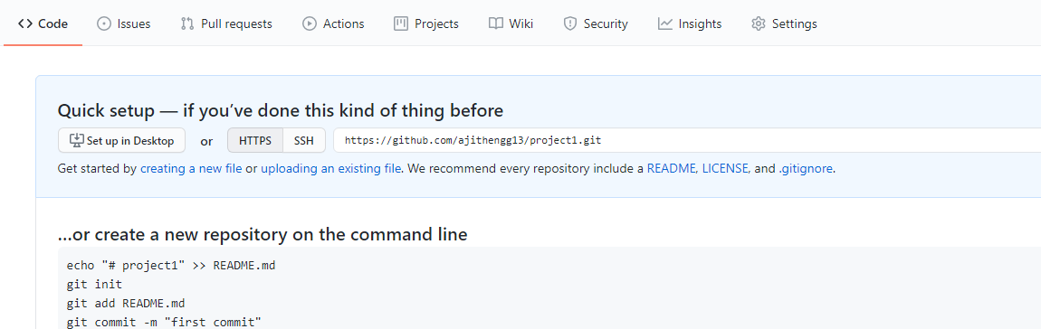

* Pushing the maven project to github repo.

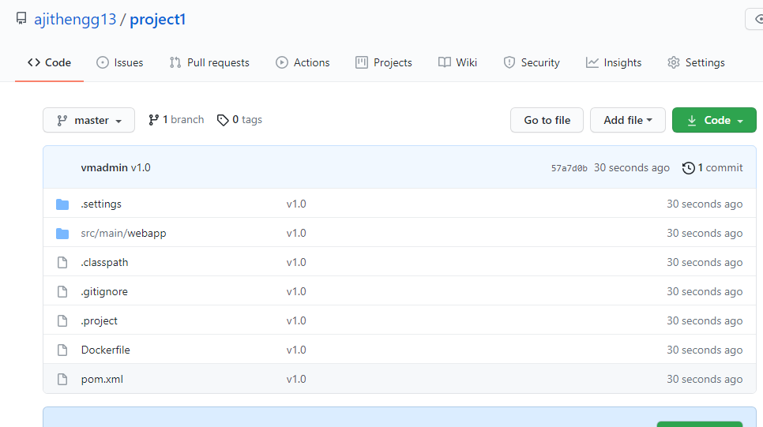

# **Part2-Phase4:**

* Commiting the project and looking for changes in the git.

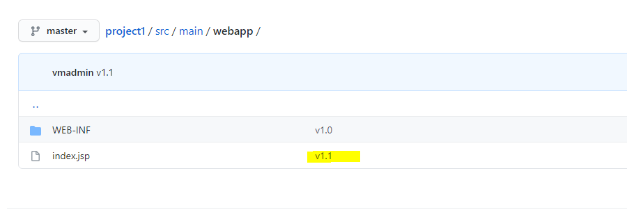

The changes made in the eclipse is reflected in the GIt Hub after push and commit.

# **Part 2- Phase 5**

* Configuring ansible in build server:

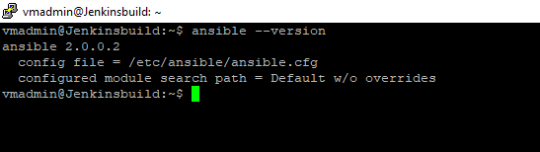

* Modifying Ansible.cfg to configure host file.

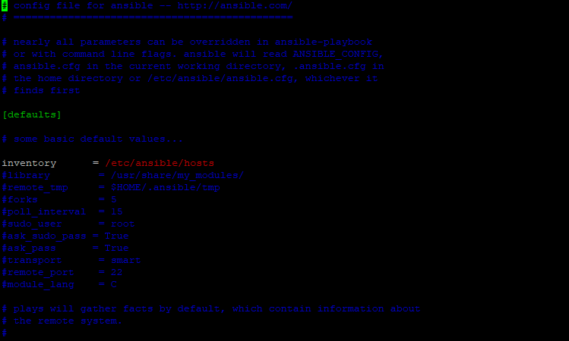

* Creating azure service principle for Ansible.

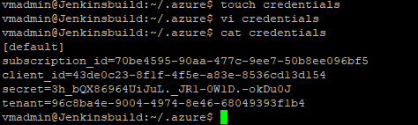

# **Part2-phase:6**

* Pushing all the playbooks to github.

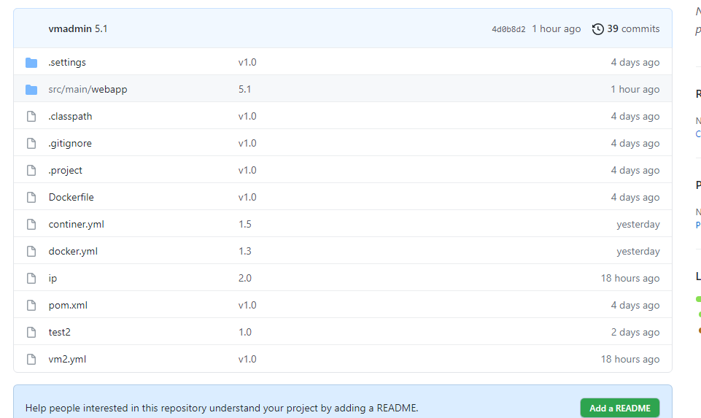

# **Part2-phase:7**

* Testing of all the Runbooks which is created to Create a vm and docker continer .

# **Part2-phase-8:**

* Creation of repo in hub.docker.com.

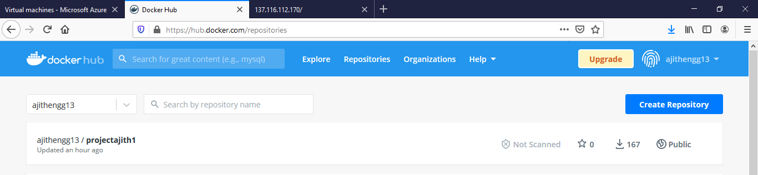

* Creation of pipeline one.

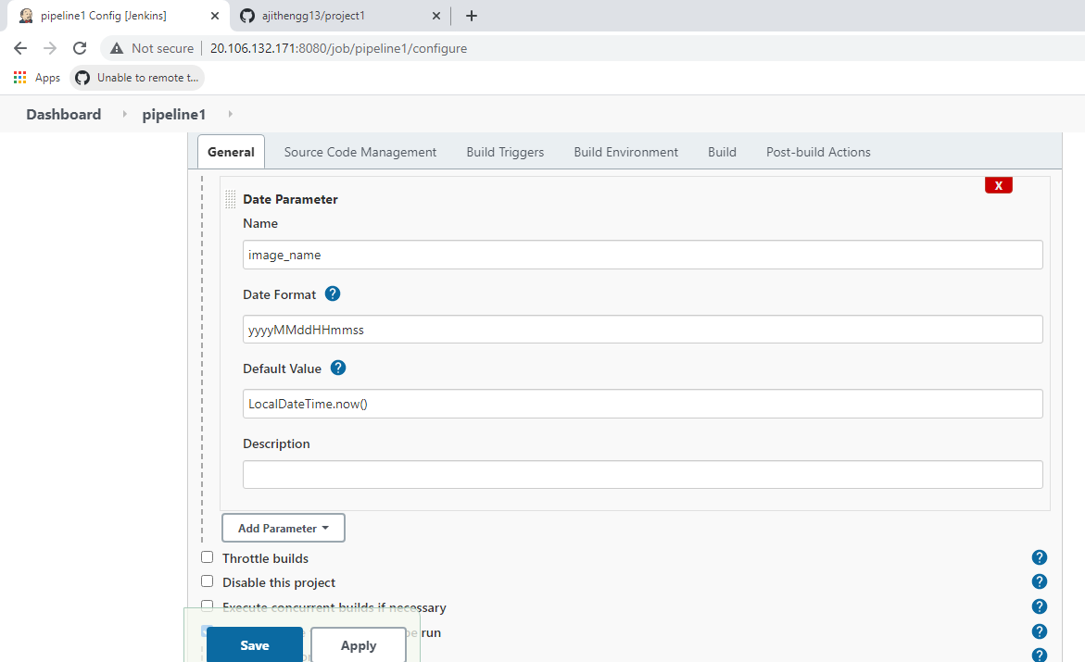

* Creation of pipeline two.

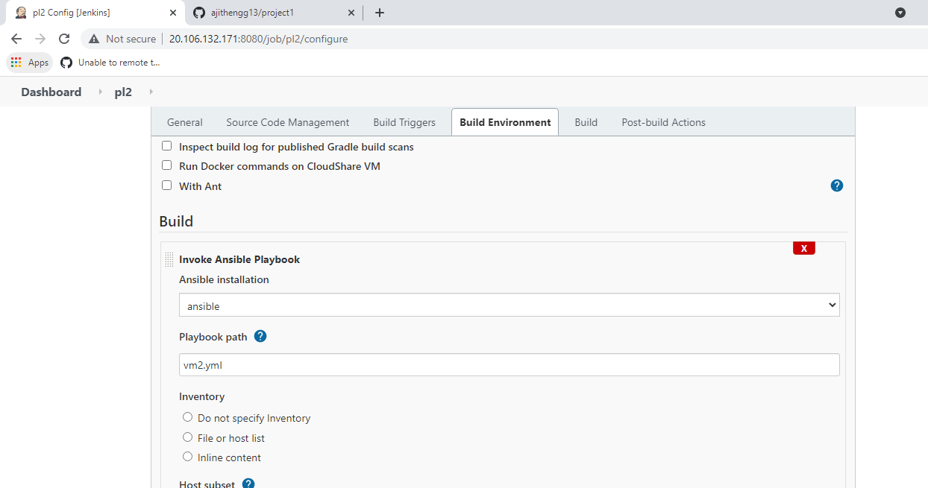

* Creation of parent child link.

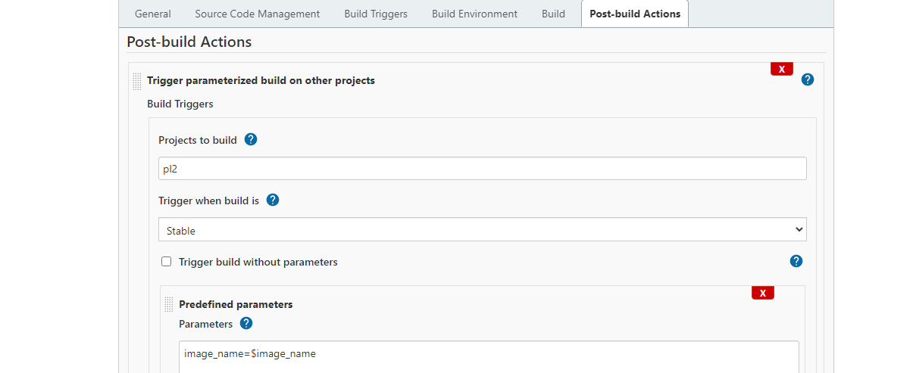

* Creation of CI/CD with webhook.

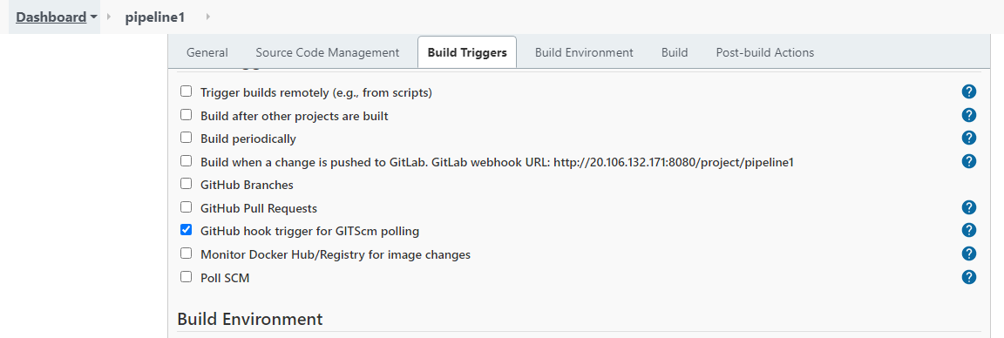

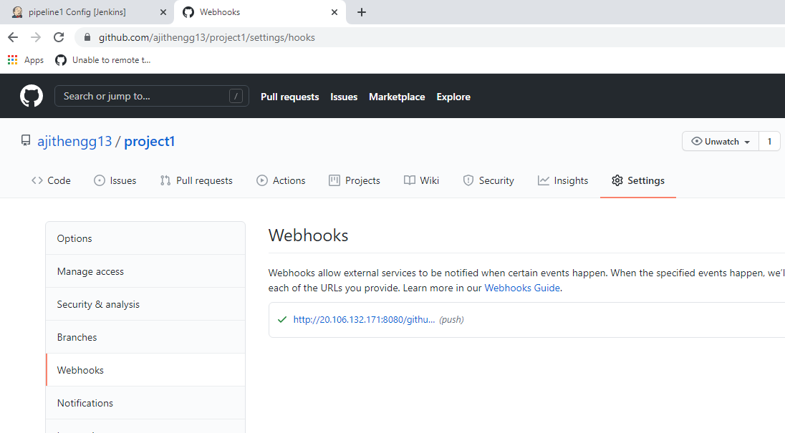

* Accessing the App using Browser.

